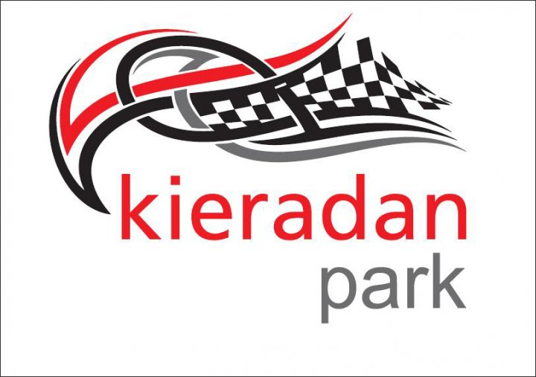

TO ENABLE US TO CONTINUE OPERATING, WE HAVE AGREED WITH THE COUNCIL TO CLOSE ON THE FOLLOWING DATES FOR PRACTICE

Saturday 1st & Sunday 2nd May 2021
***
Saturday 29th & Sunday 30th May 2021
***
Saturday 3rd & Sunday 4th July 2021

Saturday 24th & Sunday 25th July 2021
***
Saturday 31st July 2021
***
Saturday 28th & Sunday 29th August 2021
***
Saturday 18th September 2021
***
Sunday 14th November 2021

All other opening dates are weather dependent.

Many thanks

Cheryl

